

Requirement & Design Specification

**Student Project Portal System (SPPS)**

**Version: 3.0**

– Hanoi, September 2023 –

**Contents**

Record of Changes 4

I. Overview 5

1. Overall Description 5

1.1 Product Overview 5

1.2 Business Rules 5

2. User Requirements 6

2.1 Actors 6

2.2 Use Cases 7

a. Use Case Diagram(s) 7

b. Descriptions 12

3. Overall Functionalities 21

3.1 Screens Flow 21

3.2 Screen Descriptions 21

3.3 Screen Authorization 24

3.4 Non-UI Functions 25

3.5 Entity Relationship Diagram 25

4. System High Level Design 27

4.1 Database Design 27

4.1.1. Database Schema 27

4.1.1. Table Descriptions 27

4.2 Code Packages 28

4.2.1. Package Diagram 28

4.2.1. Package descriptions 28

II. Requirement Specifications 30

1. User and Access Management 30

1.1 UC-03_Login System 30

2. System Setting Management 31

2.1 UC-22_Add system settings 31

2.2 UC-22_View system settings 32

3. Subject Management 33

3.1 UC-25_View Subject Assignment List 33

3.2 UC-26_Add Subject Assignment 34

4. Class Management 35

4.1 UC-37_Add New Class 35

4.2 UC-38_Update Class Details 36

5. Project Management 37

6. Synchronization 37

III. Design Specifications 38

1. User and Access Management 38

1.1 System Access 38

a. User Login 38

2. System Setting Management 39

3. Subject Management 39

4. Class Management 39

5. Project Management 39

6. Synchronization 39

IV. Appendix 40

1. Assumptions & Dependencies 40

2. Limitations & Exclusions 40

3. Messages List 41

# 

# **Record of Changes**

| **Version** | **Date** | **A* M, D** | **In charge** | **Change Description** |
| --- | --- | --- | --- | --- |
| V1.0 | 16/09 | A | HungLQHE161677 | Actors, UC Diagram - Description for admin role. |
| V1.0 | 18/09 | A | HungLQHE161677 | Database V1 |
| V1.0 | 23/09 | A | HungLQHE161677 | UC Diagram for Subject Manager role. |
| V1.0 | 24/09 | A | NgocPTBHE176778 | UC Description for Student role. |
| V1.0 | 24/09 | A | MinhLVHHE163657 | UC Description for Team Leader role. |
| V1.0 | 24/09 | A | HungLQHE161677 | UC Diagram for Student role (include Team Leader). |
| v1.0 | 25/09 | A | DatNVHE176009 | Code Package Diagram |
| v2.0 | 22/10 | M | DatNVHE176009 | Database Design |
| v2.0 | 22/10 | A | NgocPTBHE176778 | Product Overview, Screenflow |
| v3.0 | 25/10 | A | NgocPTBHE176778 | Entity Relationship |
| v3.0 | 25/10 | A | MinhLVHHE163657 | Business Rules |
| v3.0 | 25/10 | M | DatNVHE176009 | Actors, Use Case Diagram, Non-UI Functions |
| v3.0 | 26/10 | M | DatNVHE176009 | UC Diagram - Description,  Screen Description - Authorization |
| v3.0 | 26/10 | A | DatNVHE176009 | Requirement Specifications - Class |
| v3.0 | 26/10 | A | NgocPTBHE176778 | Requirement Specifications - Subject |
| v3.0 | 26/10 | A | MinhLVHHE163657 | Requirement Specifications - System Setting |
| v3.0 | 27/10 | M | DatNVHE176009 | Package Diagram |

*A - Added M - Modified D - Deleted

# 

# **Overview**

## **Overall Description**

### **1.1 Product Overview**

The context diagram of our SPP project management software illustrates its external interactions with administrators, management instructors, and students. This diagram visually represents the data flows, demonstrating the intricate workings of the SPP system as teachers and students engage with the program. Through this diagram, we can observe how teachers and students utilize the system to manage projects efficiently. The user-friendly SPP Project Management System plays a crucial role in enhancing student project management, offering robust features and intuitive tools for optimal project supervision and coordination.

### **1.2 Business Rules**

| **ID** | **Rule Definition** |
| --- | --- |
| BR-01 | Students must submit their project and assignments before the assigned deadlines. Late submissions will result in a deduction of marks. |
| BR-02 | Assignments must be delivered through the online system; physical submissions are not accepted. |
| BR-03 | Students are allowed to request late submission with a valid reason. However, there are specific time frames. |
| BR-04 | Students may submit assignments late, but points will be deducted at a flat rate for each day late. |
| BR-05 | Students will be graded based on the quality of their assignments and adherence to deadlines. |
| BR-06 | Each member of the group is expected to contribute equally. Assessments should include an evaluation of individual contributions. |
| BR-07 | Project and assignment must have a size less than 50MB. |
| BR-08 | Students will receive feedback within two weeks of assignment submission. |
| BR-09 | Students can request re-submission within assigned deadlines of receiving feedback, and the highest possible grade for re-submissions is capped at a certain percentage. |
| BR-10 | Assignment scores must not be publicly disclosed but should be accessible only to the individual student. |
| BR-11 | Ensure that student personal data is secure and complies with data protection regulations. |

## **User Requirements**

### **2.1 Actors**

| **#** | **Actor** | **Description** |
| --- | --- | --- |
| 1 | Guest | Users who have not logged in the system. |
| 2 | Registered User | Users who can login and access the system's features. |
| 3 | Administrator | Users who can manage users, subjects and system settings. |
| 4 | Subject Manager | Users who can manage classes, subject settings, subject assignments. |
| 5 | Class Manager | Users who can manage assigned classes,class issue settings, class students, projects, project members. |
| 6 | Project Mentor | Users who can manage assigned projects, evaluate project submisions. |
| 7 | Team Leader | Users who can manage project milestones, project issue settings, and submit assignment results. |
| 8 | Student | Users who can manage project issues, manage work updates, view assignment details. |

### 

### **2.2 Use Cases**

#### **a. Use Case Diagram(s)**

|  |
| --- |
|  |
|  |
|  |
|  |
|  |
|  |
|  |

#### **b. Descriptions**

| **ID** | **Use Case** | **Actors** | **Use Case Description** |
| --- | --- | --- | --- |
| UC-1 | View Landing Page | Guest | Users first see this page. |
| UC-2 | Register User | Guest | Register new user to access feature of system |
| UC-3 | Login System | Registered User | Provide authentication and authorization for registered user |
| UC-4 | Login With Google | Registered User | Provide authentication and authorization by Google for registered user |
| UC-5 | Reset Password | Registered User | Reset and create new password in case of forgetting the old one |
| UC-6 | View Dashboard | Registered User | Users can see the information and statistics. |
| UC-7 | Logout | Registered User | Users who logged in can logout the system. |
| UC-8 | View Profile | Registered User | Users who logged in can view his/her profile. |
| UC-9 | Update Profile | Registered User | Users can update their profile. |
| UC-10 | Change Password | Registered User | Users can change their password. |
| UC-11 | View User List | Admin | Admin can see a list of all users. |
| UC-12 | View User Detail | Admin | Admin clicks on each user in the list to see details. |
| UC-13 | Change Status User | Admin | Admin can change the status of the user's account. |
| UC-14 | Update User Info | Admin | Admin can update user information. |
| UC-15 | View Subject List | Admin | Admin can see a list of all subjects. |
| UC-16 | View Subject Detail | Admin, Subject Manager | Admin and subject manager clicks on each subject in the list to see detail. |
| UC-17 | Add Subjects | Admin, Subject Manager | Admin and subject manager can add new subjects. |
| UC-18 | Update Subjects | Admin, Subject Manager | Admin and subject manager can update subject information. |
| UC-19 | Change Status Subjects | Admin, Subject Manager | Admin and subject manager can activate or deactivate the subject. |
| UC-20 | View Setting List | Admin | Admin can see a list of all system settings. |
| UC-21 | View Setting Detail | Admin | Admin clicks on each setting in the list to see detail. |
| UC-22 | Add System Settings | Admin | Admin can add new settings. |
| UC-23 | Update System Settings | Admin | Admin can update settings. |
| UC-24 | Change Status System Settings | Admin | Admin can activate or deactivate. |
| UC-25 | View Subject Assignment List | Admin, Subject Manager | The Subject Manager can see a list of subject assignments. |
| UC-26 | Add Subject Assignment | Admin, Subject Manager | The Subject Manager can add new subject assignments. |
| UC-27 | Update Subject Assignment | Admin, Subject Manager | The Subject Manager can update subject assignments. |
| UC-28 | Delete Subject Assignment | Admin, Subject Manager | The Subject Manager can delete subject assignments. |
| UC-29 | View Assignment Details | Admin, Subject Manager, Student | The Subject Manager and students can delete subject assignments. |
| UC-30 | View List Subject Settings | Admin, Subject Manager | The Subject Manager can see a list of subject settings. |
| UC-31 | View Subject Setting Details | Admin, Subject Manager | The Subject Manager can see subject settings details. |
| UC-32 | Add Subject Setting | Admin, Subject Manager | The Subject Manager can add a new subject setting. |
| UC-33 | Update Subject Setting | Admin, Subject Manager | The Subject Manager can update subject settings. |
| UC-34 | Change Status Subject Setting | Admin, Subject Manager | The Subject Manager can active/deactive subject settings. |
| UC-35 | View List Classes | Admin, Subject Manager | The Subject Manager can see a list of classes. |
| UC-36 | Add New Class | Admin, Subject Manager | The Subject Manager can add a new class. |
| UC-37 | Update Class Details | Admin, Subject Manager | The Subject Manager can update classes. |
| UC-38 | Update Class Assignment | Admin, Subject Manager | The Subject Manager can update class assignments. |
| UC-39 | Change Status Class | Admin, Subject Manager | The Subject Manager can start or cancel class. |
| UC-40 | View List Assigned Classes | Admin, Class Manager | Class Manager can see assigned classes |
| UC-41 | Update Class Description | Admin, Class Manager | Class Manager can update class description. |
| UC-42 | Update Class Assignments | Admin, Class Manager | Class Manager can change information of class assignments |
| UC-43 | View List Project Member | Admin, Class Manager | Class Managers can view the list of members assigned to a specific project. |
| UC-44 | Remove Member | Admin, Class Manager | Class Managers can remove members from a class or project. |
| UC-45 | Import Member From Excel | Admin, Class Manager | Class Managers can import member information from an Excel file. |
| UC-46 | Assign Member As Leader | Admin, Class Manager | Class Managers can assign a member as the leader of a project or class. |
| UC-47 | Move Member To Other Project | Admin, Class Manager | Class Managers can transfer a member from one project or class to another. |
| UC-48 | Update Project's Member With Note | Admin, Class Manager | Class Managers can update a project's member records with relevant notes. |
| UC-49 | View List Issue Settings | Admin, Class Manager, Team Leader | Class Managers, and Team Leaders can view a list of issue settings. |
| UC-50 | Add Issue Setting | Admin, Class Manager, Team Leader | Class Managers, and Team Leaders can add new issue settings. |
| UC-51 | Update Issue Settings | Admin, Class Manager, Team Leader | Class Managers, and Team Leaders are authorized to modify and update existing issue settings as needed. |
| UC-52 | Change Status Issue Settings | Admin, Class Manager, Team Leader | Class Managers, and Team Leaders can modify the status of issue settings. |
| UC-53 | View Issue Setting Details | Admin, Class Manager, Team Leader | Class Managers, and Team Leaders can access specific details of issue settings. |
| UC-54 | View List Project | Admin, Class Manager | Class Managers can view a list of projects. |
| UC-55 | Add Project | Admin, Class Manager | Class Managers can add new projects. |
| UC-56 | View Project Details | Admin, Class Manager | Class Managers can access and review project details. |
| UC-57 | Change Status Project | Admin, Class Manager, Project Mentor | Class Managers, and Project Mentors can change the status of a project. |
| UC-58 | Delete Inactive Project | Admin, Class Manager | Class Managers can delete inactive projects. |
| UC-59 | Update Project Details | Admin, Class Manager, Project Mentor | Class Managers, and Project Mentors can update project details. |
| UC-60 | View List Class Student | Admin, Class Manager | Class Manager can see list of student that has signed up to the class |
| UC-61 | Add Student To Class | Admin, Class Manager | Subject Manager can add student to the specific class he/shemanage |
| UC-62 | View Student Details | Admin, Class Manager | Class Managers can access detailed information about students. |
| UC-63 | Update Class Student Status With Note | Admin, Class Manager | Class Managers can update the status of class students, including adding notes as needed. |
| UC-64 | Import List Class Student | Admin, Class Manager | Class Managers can import a list of class students from excel. |
| UC-65 | Export List Class Student | Admin, Class Manager | Subject Manager can export list class student to excel file |
| UC-66 | View List Assigned Projects | Admin, Project Mentor | Project Mentor can access a list of projects assigned to students. |
| UC-67 | View Project Details | Admin, Project Mentor | Project Mentor can access details of specific projects. |
| UC-68 | Change Team Leader | Admin, Project Mentor | Project Mentors can change the team leader for a project. |
| UC-69 | View Submission | Admin, Project Mentor | Project Mentors can view student submissions. |
| UC-70 | Evaluate Submission | Admin, Project Mentor | Project Mentors can evaluate student submissions. |
| UC-71 | Download Submission | Admin, Project Mentor | Project Mentors can download student submissions. |
| UC-72 | Reject Submission | Admin, Project Mentor | Project Mentors can reject student submissions. |
| UC-73 | Submit Assignment Result | Team Leader | Team Leader can submit assignment results. |
| UC-74 | View List Milestones | Team Leader | Team Leader can view a list of project milestones. |
| UC-75 | Add Milestone | Team Leader | Team Leader can add project milestones. |
| UC-76 | Update Milestone | Team Leader | Team Leader can update project milestones. |
| UC-77 | Delete Pending Milestone | Team Leader | Team Leader can delete pending project milestones. |
| UC-78 | View List Issues | Student | Students can view a list of project issues. |
| UC-79 | Add Issue | Student | Students can add project issues. |
| UC-80 | Import Issue From Excel | Student | Students import project issues from an Excel file. |
| UC-81 | Export Issue To Excel | Student | Students can export project issues to an Excel file. |
| UC-82 | Batch Update Issue | Student | Students can perform batch updates on project issues. |
| UC-83 | Update Issue | Student | Students can update project issues. |
| UC-84 | View List Work Updates | Student | Students view a list of work updates. |
| UC-85 | Delete Work | Student | Students can delete work records. |
| UC-86 | Update Work | Student | Students can update work records. |
| UC-87 | Add Work Update | Student | Students can add work updates. |
| UC-88 | View Work Update Details | Student | Students access detailed information on work updates. |
| UC-89 | View List Assignment Milestones | Student | Students can view a list of assignment milestones. |
| UC-90 | View Evaluation | Student | Students can access and view their and other evaluations. |
| UC-91 | View Team Submission | Student | Students can view team submissions. |
| UC-92 | Gitlab Synchronization | Class Manager, Project Mentor, Team Leader, Student | Users synchronize data with Gitlab for project management purposes. |

## **3. Overall Functionalities**

### **3.1 Screens Flow**

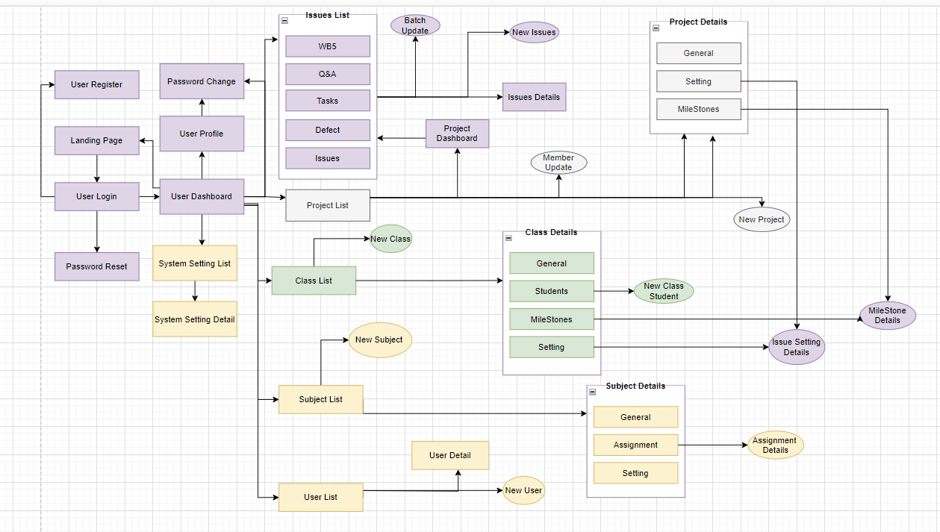

### **3.2 Screen Descriptions**

| **No** | **Feature** | **Screen** | **Description** |
| --- | --- | --- | --- |
| 1 | User and Access Management | Landing Page | * The entry point to the platform, offering an engaging introduction to its purpose. |
| 2 | User and Access Management | User Register | * Allows new users to sign up for the platform by providing necessary information. |
| 3 | User and Access Management | User Login | * Provides a secure login process for registered users to access their accounts. |
| 4 | User and Access Management | Password Reset | * Enables users to reset their forgotten passwords, ensuring account security. |
| 5 | User and Access Management | User Profile | * Allows users to view and edit their personal information and settings. |
| 6 | User and Access Management | Password Change | * Permits users to change their existing passwords for security reasons. |
| 7 | User and Access Management | Dashboard | * A personalized space displaying key data, notifications, and insights. |
| 8 | System Setting Management | Setting List | * Offers an overview of various settings available on the platform. |
| 9 | System Setting Management | Setting Detail | * Allows users to configure and modify specific settings in detail. |
| 10 | User and Access Management | User List | * Provides a list of all users registered on the platform. |
| 11 | User and Access Management | New User | * A screen for administrators to add new users to the system. |
| 12 | User and Access Management | User Detail | * Offers detailed information about a specific user. |
| 13 | Subject Management | Subject List | * Displays a list of subjects or topics on the platform. |
| 14 | Subject Management | New Subject | * Allows the addition of new subjects or topics. |
| 15 | Subject Management | Subject Detail | * Subject Detail: Provides comprehensive information about a specific subject. |
| 16 | Subject Management | Subject Setting Detail | * Allows customization of settings for a particular subject. |
| 17 | Subject Management | Assignment Detail | * Displays detailed information about assignments, tasks, or projects. |
| 18 | Class Management | Class List | * Lists all classes or groups on the platform. |
| 19 | Class Management | New Class | * Enables the creation of a new class or group. |
| 20 | Class Management | Class Detail | * Offers a comprehensive view of a specific class or group. |
| 21 | Class Management | New Class Student | * Allows the addition of students to a class. |
| 22 | Project Management | Project Allocation | * Manages the allocation of projects to users or groups. |
| 23 | Project Management | New Project | * Provides the ability to create new projects on the platform. |
| 24 | Project Management | Project List | * Lists all projects available on the platform. |
| 25 | Project Management | Project detail | * Offers detailed insights into a specific project. |
| 26 | Issue Management | Issue Setting List | * Displays available issue settings or configurations. |
| 27 | Issue Management | Issue Setting Detail | * Allows customization of issue settings in detail. |
| 28 | Project Management | Milestone List | * Lists all milestones achieved or in progress. |
| 29 | Project Management | Milestone Detail | * Provides detailed information about a specific milestone. |
| 30 | Synchronization | Group Label Sync | * Manages synchronization of labels for groups. |
| 31 | Synchronization | Group Milestone Sync | * Manages synchronization of milestones for groups. |
| 32 | Synchronization | Project Label Sync | * Manages synchronization of labels for projects. |
| 33 | Synchronization | Project Milestone Sync | * Manages synchronization of milestones for projects. |
| 34 | Synchronization | Project Issue Sync | * Manages synchronization of issues for projects. |

### **3.3** **Screen Authorization**

| **Screen** | **Admin** | **Subject Manager** | **Class Manager** | **Project Mentor** | **Team Leader** | **Student** |
| --- | --- | --- | --- | --- | --- | --- |
| Landing Page | x | x | x | x | x | x |
| User Register | x | x | x | x | x | x |
| User Login | x | x | x | x | x | x |
| Password Reset | x | x | x | x | x | x |
| User Profile | x | x | x | x | x | x |
| Password Change | x | x | x | x | x | x |
| Dashboard | x | x | x | x | x | x |
| Setting List | x |  |  |  |  |  |
| Setting Detail | x |  |  |  |  |  |
| User List | x |  |  |  |  |  |
| New User | x |  |  |  |  |  |
| User Detail | x |  |  |  |  |  |
| Subject List | x | x |  |  |  |  |
| New Subject | x | x |  |  |  |  |
| Subject Detail | x | x |  |  |  |  |
| Subject Setting Detail | x | x |  |  |  |  |
| Assignment Detail | x | x | x |  | x | x |
| Class List | x | x |  |  |  |  |
| New Class | x | x |  |  |  |  |
| Class Detail | x | x | x |  |  |  |
| New Class Student | x | x | x |  |  |  |
| Project Allocation | x | x | x |  |  |  |
| New Project | x | x | x |  |  |  |
| Project List | x | x | x | x |  |  |
| Project detail | x | x | x | x | x | x |
| Issue Setting List | x | x | x |  | x |  |
| Issue Setting Detail | x | x | x |  | x |  |
| Milestone List | x | x | x |  | x |  |
| Milestone Detail | x | x | x |  | x | x |
| Group Label Sync | x | x | x |  | x |  |
| Group Milestone Sync | x | x | x |  | x |  |
| Project Label Sync | x | x | x |  | x |  |
| Project Milestone Sync | x | x | x |  | x |  |
| Project Issue Sync | x | x | x |  | x |  |

### **3.4 Non-UI Functions**

| **No** | **Feature** | **System Function** | **Description** |
| --- | --- | --- | --- |
| 1 | Verification | Send Email Verification | After registering, send an email which contains a link to verify for the user. Without verification, users can not use any feature of this system. |
| 2 | Authentication | Token-based Authentication | After signing in, users will access this system with better security by JWT security. |
| 3 | Authorization | Role and Permission Management | Define user roles and permissions to provide access to system features. |

### **3.5 Entity Relationship Diagram**

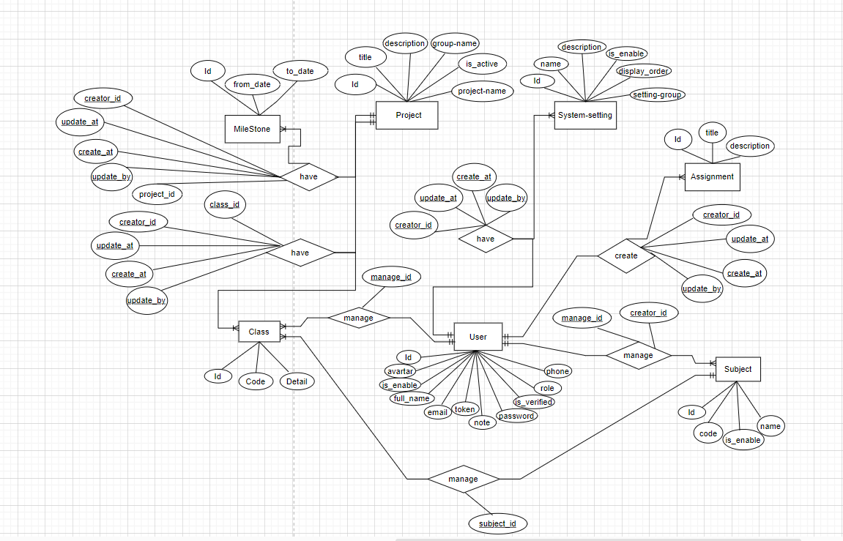

| **No** | **Entity** | **Description** |
| --- | --- | --- |
| 1 | User | A basic entity in an application's database structure that represents an individual user interacting with the system. This table stores important user information and forms the basis for authentication, role assignment to individuals, authorization, and user personalization. |
| 2 | Subject | An entity with the role of subject manager, representing the user who manages the assigned subject. |
| 3 | Class | An entity with the role of class manager, representing the user who manages the assigned class and is the lecture |
| 4 | Project | Projects assigned by the class manager to each group in the class are participated in by student members in the class. |
| 5 | Milestone | Milestones are for projects that have a start time and an end time and can be regularly updated by the project creator. |
| 6 | Assignment | Assignments are assigned to subjects or classes and are created by the subject manager or class manager |
| 7 | System-setting | Consists of semesters, permitted email domains and all the system roles |

## 

## **4. System High Level Design**

### **4.1 Database Design**

#### **4.1.1. Database Schema**

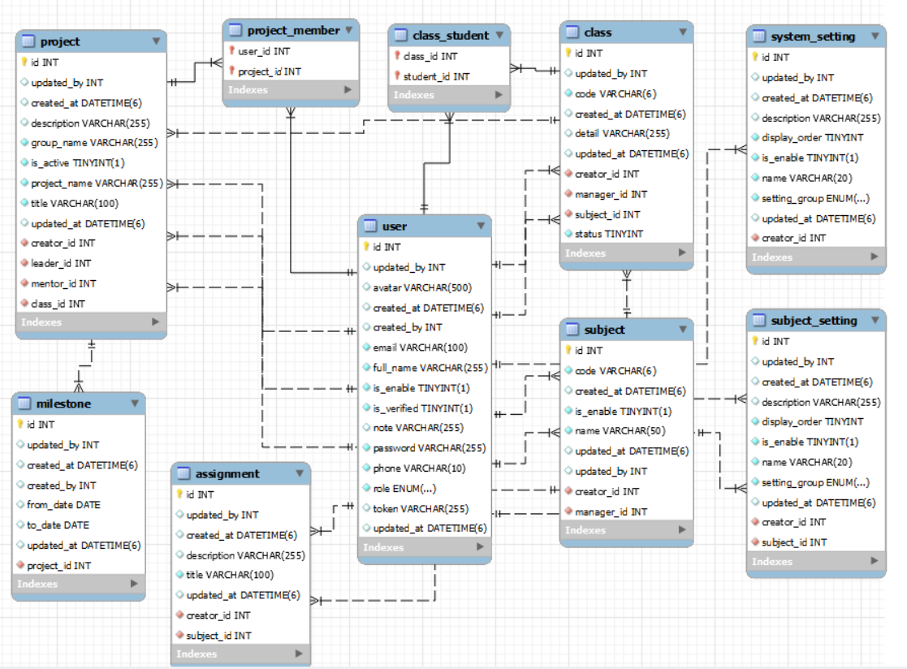

#### **4.1.1. Table Descriptions**

| **No** | **Table** | **Description** |
| --- | --- | --- |
| *01* | *<Table name>* | *<Description of the table>*  *- Primary keys: <<list of primary key fields>>*  *- Foreign keys: <<list of foreign key fields>>* |
| *02* | *<Table name2>* | *…* |

### **4.2 Code Packages**

#### **4.2.1. Package Diagram**

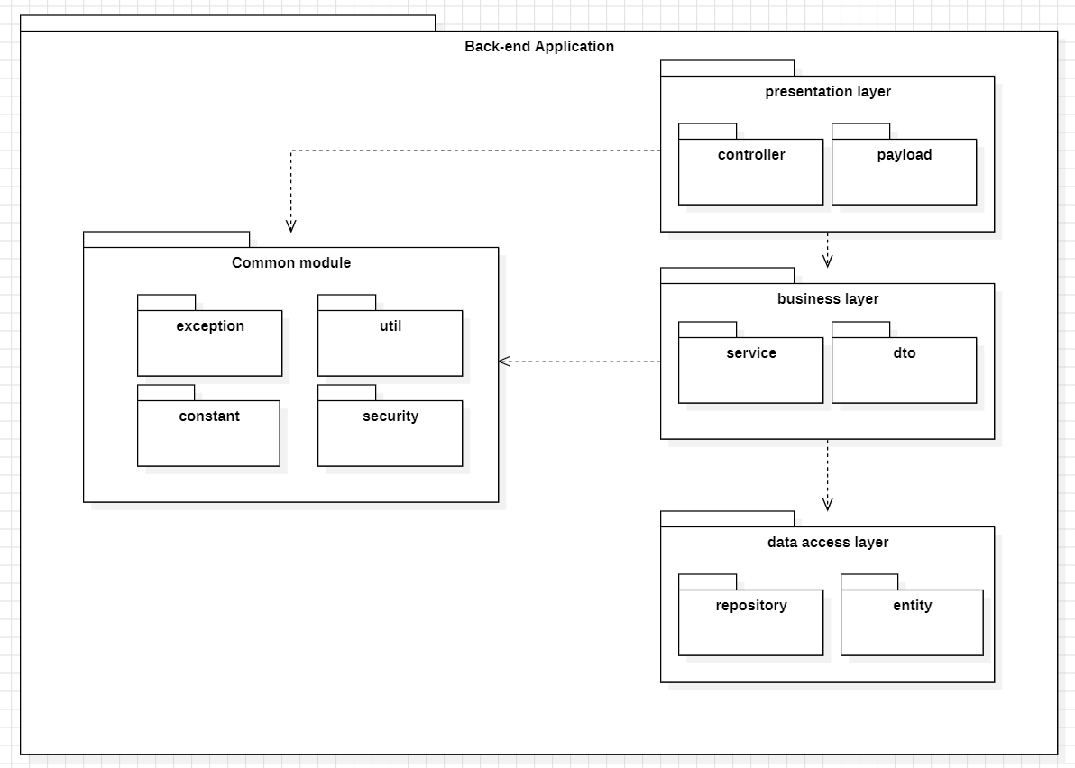

#### **4.2.1. Package descriptions**

| **No** | **Package** | **Description** |
| --- | --- | --- |
| 01 | controller | Contains classes responsible for handling HTTP requests and managing the application's request-routing logic. |
| 02 | exception | Houses classes and exception types used to handle and manage exceptional situations in the application |
| 03 | payload | Contains classes used for transferring data between controllers, services, or other components in the application |
| 04 | constant | Stores classes or files holding constants and fixed values used throughout the application. |
| 05 | entity | Contains classes representing data objects or database tables. These classes are typically mapped to the database. |
| 06 | service | Holds the business logic of this application. |
| 07 | serviceImpl | Contains the implementations of the service interfaces. These classes implement the methods defined in the service interfaces and contain the specific business logic of the application. |
| 08 | security | Encapsulates security-related components that safeguard the application against a wide range of security threats and vulnerabilities. |
| 09 | util | Contains utility classes and methods that provide common functionality used across different parts of the application. Here is data encoded and encrypted. |
| 10 | repository | Contains classes responsible for database interaction, such as CRUD operations on entities. These classes often use Spring Data JPA or a similar technology for data access. |

# **II. Requirement Specifications**

## **User and Access Management**

### **1.1 UC-03_Login System**

| UC ID and Name | **UC-03_Login System** | | |
| --- | --- | --- | --- |
| Created By |  | Date Created: | 26/Oct/2023 |
| Primary Actor | Registered User | Secondary Actors: | None |
| Trigger | User clicks “Join us” button from the landing page, or  User accesses an authenticated feature (from a link or type the page URL directly into the address bar) | | |
| Description | As a user, I want to be able to log into the system so that I can use the system’s authenticated features and access my personalized account. | | |
| Preconditions | User account has been created & verified | | |
| Postconditions | User logs in the system successfully and redirect to dashboard | | |
| Normal Flow | **Login System**  1. User accesses the User Login screen  2. User types in the login details  3. User clicks the Login button  4. System validates the login details (see 2.0.E1)  5. System allows user to access  6. System accesses the Dashboard page | | |
| Alternative Flows | ***Google Login***  1. User chooses to login system using Google account  2. System redirects the user to the Google’s Login screen  3. User types in the Google account details and chooses to login  4. Google validates user’s login information successfully and redirect him/her back to the system  5. Return to step 5 of normal flow. | | |
| Exceptions: | 1. If system can’t authenticate the user, an error message is shown to the user  2. User cancels the logging in *=> UC stops, change to UC-1_View Home Page*  3. User clicks “Forgot Password?” link *=> change to UC-3_Reset Password*  4. User clicks “Register” link *=> change to UC-4_Register User Account* | | |
| Priority: | Must Have | | |
| Frequency of Use: |  | | |
| Business Rules: |  | | |
| Other Information: |  | | |
| Assumptions: |  | | |

### **1.2 UC-11_View User List**

| UC ID and Name | **UC-11_View User List** | | |
| --- | --- | --- | --- |
| Created By | ThanhLM | Date Created: | 26/Oct/2023 |
| Primary Actor | Admin | Secondary Actors: |  |
| Trigger | User navigates to the User List screen. | | |
| Description | As a admin, I want to be able to list user with basic information | | |
| Preconditions | The user must log into the system with an account granted admin rights. | | |
| Postconditions | the user sees a comprehensive and accurate list of users in the system. This list includes relevant information like usernames, roles, and account status. | | |
| Normal Flow | 1. The user clicks on "user list" on the main screen navbar on the left side of the dashboard page. 2. The screen displays user lists arranged in order of creation 3. Users view the user lists that have been created. | | |
| Alternative Flows | None | | |
| Exceptions: | * Display error if user lacks permission. * Show error for database connection problems. * Inform if no users are found. * Notify if the searched user does not exist. * Display generic error message and log details for admins. | | |
| Priority: | Importance | | |
| Frequency of Use: | Daily to Regularly | | |
| Business Rules: | * Only users with the role of "Administrator" have the permission to view the user list. * The user list should display accurate and up-to-date information about users, ensuring that it reflects the current state of the system's user database. | | |
| Other Information: |  | | |
| Assumptions: |  | | |

### **1.3 UC-14_Update User Info**

| UC ID and Name | **UC-14_Update User Info** | | |
| --- | --- | --- | --- |
| Created By | ThanhLM | Date Created: | 26/Oct/2023 |
| Primary Actor | Admin | Secondary Actors: |  |
| Trigger | Admin navigates to the user management dashboard and selects the user management and updates user details by clicking the “Edit” button. | | |
| Description | As an admin, I want to modify user details for other users and facilitate updates and ensure data accuracy for users under my supervision. | | |
| Preconditions | The user must log into the system with an account granted admin rights. | | |
| Postconditions | * After a successful update, the user's profile is updated to reflect the changes made. * The update ensures data accuracy and integrity. * Users may receive a confirmation message. * The entry specifies the specific information modified. | | |
| Normal Flow | 1. Administrator logs in with admin credentials. 2. Navigates to the "User Management" or "Admin Dashboard" section. 3. Selects users to update. 4. Edits user information. 5. System validates updated information. 6. Saves or updates changes. 7. System updates user information in the database. 8. Displays confirmation message. | | |
| Alternative Flows | None | | |
| Exceptions: | If the user lacks the required permissions to update user details, the use case ends with an error message.  In case of technical issues during the update process, the use case concludes with an error message. | | |
| Priority: | Importance | | |
| Frequency of Use: | Occasional | | |
| Business Rules: | -Only users with the role of "Administrator" have the permission to view the user list.   * Updated data must meet specified formats and limits. | | |
| Other Information: |  | | |
| Assumptions: |  | | |

## **System Setting Management**

### **2.1 UC-22_Add system settings**

| UC ID and Name: | **UC-22_Add system settings** | | |
| --- | --- | --- | --- |
| Created By: | Minhlvh | Date Created: | 10/Oct/2023 |
| Primary Actor: | Admin | Secondary Actors: |  |
| Trigger: | 1.User click the add button from the page system setting manager 2. The user clicks on the “Setting Add” in the left navbar | | |
| Description: | As a admin, I want to be able to create new system setting so that I can add new field in user setting | | |
| Preconditions: | PRE-1. Admin is logged into the system.  PRE-2. Admin fill information valid with form. | | |
| Postconditions: | POST-1. Admin create new system setting successfully | | |
| Normal Flow: | 1.In dashboard, Admin click on the “system setting”  2.System setting will drop-down for Admin two options then Admin click on the “Setting add”  3.Admin accesses the New system setting screen  4.Admin types in the system setting details  5. Admin clicks the Submit button  6. System validates the system setting details (see E.1)  7. System allows user add new system setting  8.The system redirects the user to the system settings manager page | | |
| Alternative Flows: | **A.1 Back to the System setting manager page**  1. Click to the sub-link under the header of page | | |
| Exceptions: | ***E.1 System can’t add new system setting***  1. The Error Message screen is shown to the user | | |
| Priority: | High | | |
| Frequency of Use: |  | | |
| Business Rules: |  | | |
| Other Information: |  | | |
| Assumptions: |  | | |

### **2.2 UC-22_View system settings**

| UC ID and Name: | **UC-1_View system settings** | | |
| --- | --- | --- | --- |
| Created By: | Minhlvh | Date Created: | 10/Oct/2023 |
| Primary Actor: | Admin | Secondary Actors: |  |
| Trigger: | The user clicks on the “Setting List” in the left navbar | | |
| Description: | As a admin, I want to be able to list system setting so that I can manage system setting | | |
| Preconditions: | PRE-1. Admin is logged into the system.  PRE-2. Admin fill information valid with form. | | |
| Postconditions: | POST-1. Admin create new system setting successfully | | |
| Normal Flow: | 1.In dashboard, Admin click on the “system setting”  2.System setting will drop-down for Admin two options then Admin click on the “Setting list”  3.Admin accesses the System setting manage screen | | |
| Alternative Flows: | **A.1 Back to the Dashboard page**  1. Click to the sub-link under the header of page | | |
| Exceptions: |  | | |
| Priority: | High | | |
| Frequency of Use: |  | | |
| Business Rules: |  | | |
| Other Information: |  | | |
| Assumptions: |  | | |

## **Subject Management**

### **3.1 UC-14_Add New Subject**

| UC ID and Name | **UC-14_Add New Subject** | | |
| --- | --- | --- | --- |
| Created By | DatNV | Date Created: | 26/Oct/2023 |
| Primary Actor | Admin | Secondary Actors: |  |
| Trigger | User navigates to the Subject List screen and selects the "Add New Subject" option. | | |
| Description | As a user, I want to add a new subject to the system so that I can manage and provide information about the new subject. | | |
| Preconditions | The user must be logged into the system with appropriate permissions. | | |
| Postconditions | A new subject is successfully added to the system, and its details are saved in the database. | | |
| Normal Flow | 1. User selects the "Add New Subject" button. 2. The system displays a form for entering Subject Details. 3. The user fills in the required information. 4. The user submits the form. 5. The system validates the data and saves the new subject details in the database. 6. The system confirms the successful addition of the new subject. | | |
| Alternative Flows | None | | |
| Exceptions: | * If the user lacks the necessary permissions to add a new subject, an error message is displayed, and the use case terminates. * If there are technical issues during the data validation or database save process, an error message is shown, and the use case terminates. | | |
| Priority: | Importance | | |
| Frequency of Use: | Occasional | | |
| Business Rules: | * Only users with the role of "Administrator" or "Subject Manager" have the permission to add new subjects. * Data entered for the new subject must adhere to data validation rules, including proper date and time formats. * The system will assign a unique identifier to each new subject added. * Subject names must be unique to avoid naming conflicts. | | |
| Other Information: |  | | |
| Assumptions: |  | | |

### **3.2 UC-15_Update Subject Details**

| UC ID and Name | **UC-15_Update Subject Details** | | |
| --- | --- | --- | --- |
| Created By | DatNV | Date Created: | 26/Oct/2023 |
| Primary Actor | Subject Manager | Secondary Actors: | Admin |
| Trigger | User navigates to the subject management dashboard and selects the option and update subject details by clicking “Edit” button. | | |
| Description | As an authorized user, I want to update subject details so that I can ensure accurate and up-to-date information for subjects, including subject names, subject code and related details, to enhance the user experience for students. | | |
| Preconditions | * The user must be logged into the system. * The user must have the necessary permissions to edit subject details. * The subject to be updated must already exist in the system. | | |
| Postconditions | * The subject details are updated in the system's database. * Users viewing the subject information will see the updated details. | | |
| Normal Flow | 1. The system displays a list of subjects or subject details, depending on the user's entry point. 2. The user selects the specific subject they want to update. 3. The system provides a form with editable fields for the subject details. 4. The user makes the desired changes to the subject information. 5. The user confirms and submits the changes. 6. The system updates the subject details in the database. | | |
| Alternative Flows | None | | |
| Exceptions: | If the user lacks the required permissions to update subject details, the use case ends with an error message.  In case of technical issues during the update process, the use case concludes with an error message. | | |
| Priority: | Importance | | |
| Frequency of Use: | Occasional | | |
| Business Rules: | * Only authorized users with specific permissions can update subject details. * Information about the user performing the update must be recorded. | | |
| Other Information: |  | | |
| Assumptions: |  | | |

### **3.3 UC-25_View Subject Assignment List**

| UC ID and Name: | UC-25_View Subject Assignment List | | |
| --- | --- | --- | --- |
| Created By: | NgocPTB | Date Created: | 11/10/2023 |
| Primary Actor: | Subject Manager | Secondary Actors: | Admin |
| Trigger: | The user clicks on the “Assignment List” in the left navbar | | |
| Description: | This use case describes the assignment list created by the subject manager | | |
| Preconditions: | The user logs into the system and has the right to be a subject manager | | |
| Postconditions: | The user successfully accesses and creates a new assignment | | |
| Normal Flow: | 1.The user clicks on "assignment list" on the main screen navbar on the left side of the dashboard page.  2. The screen displays assignment lists arranged in order of creation  3. Users view the assignment lists that have been created. | | |
| Alternative Flows: | none | | |
| Exceptions: |  | | |
| Priority: | Medium, Must Have | | |
| Frequency of Use: |  | | |
| Business Rules: |  | | |
| Other Information: |  | | |
| Assumptions: |  | | |

### **3.3 UC-26_Add Subject Assignment**

| UC ID and Name: | UC-26 _ Add Subject Assignment | | |
| --- | --- | --- | --- |
| Created By: | NgocPTB | Date Created: | 11/10/2023 |
| Primary Actor: | Subject Manager | Secondary Actors: | Admin |
| Trigger: | The user clicks on the button on the right side of the assignment list screen | | |
| Description: | Use case describes the user as the subject manager creating the assignment | | |
| Preconditions: | The user logs into the system and has the right to be a subject manager | | |
| Postconditions: | The user successfully accesses and sees the list of existing assignments | | |
| Normal Flow: | 1.The user clicks on "assignment list" on the main screen navbar on the left side of the dashboard page and clicks on the button on the right side of the assignment list screen.  2. The screen displays the form to create a new assignment.  3.Subject manager with his/she right to create a new assignment according to form. | | |
| Alternative Flows: | none | | |
| Exceptions: |  | | |
| Priority: | Medium, Must Have | | |
| Frequency of Use: |  | | |
| Business Rules: |  | | |
| Other Information: |  | | |
| Assumptions: |  | | |

## **Class Management**

### **4.1 UC-37_Add New Class**

| UC ID and Name | **UC-37_Add New Class** | | |
| --- | --- | --- | --- |
| Created By | DatNV | Date Created: | 26/Oct/2023 |
| Primary Actor | Subject Manager | Secondary Actors: | Admin |
| Trigger | User navigates to the Class List screen and selects the "Add New Class" option. | | |
| Description | As a user, I want to add a new class to the system so that I can manage and provide information about the new class. | | |
| Preconditions | The user must be logged into the system with appropriate permissions. | | |
| Postconditions | A new class is successfully added to the system, and its details are saved in the database. | | |
| Normal Flow | 1. User selects the "Add New Class" button. 2. The system displays a form for entering class details. 3. The user fills in the required information. 4. The user submits the form. 5. The system validates the data and saves the new class details in the database. 6. The system confirms the successful addition of the new class. | | |
| Alternative Flows | None | | |
| Exceptions: | * If the user lacks the necessary permissions to add a new class, an error message is displayed, and the use case terminates. * If there are technical issues during the data validation or database save process, an error message is shown, and the use case terminates. | | |
| Priority: | Importance | | |
| Frequency of Use: | Occasional | | |
| Business Rules: | * Only users with the role of "Administrator" or "Subject Manager" have the permission to add new classes. * Data entered for the new class must adhere to data validation rules, including proper date and time formats. * The system will assign a unique identifier to each new class added. * Class names must be unique to avoid naming conflicts. | | |
| Other Information: |  | | |
| Assumptions: |  | | |

### **4.2 UC-38_Update Class Details**

| UC ID and Name | **UC-38_Update Class Details** | | |
| --- | --- | --- | --- |
| Created By | DatNV | Date Created: | 26/Oct/2023 |
| Primary Actor | Subject Manager | Secondary Actors: | Admin |
| Trigger | User navigates to the class management dashboard and selects the option and update class details by clicking “Edit” button. | | |
| Description | As an authorized user, I want to update class details so that I can ensure accurate and up-to-date information for classes, including class names, class code and related details, to enhance the user experience for students. | | |
| Preconditions | * The user must be logged into the system. * The user must have the necessary permissions to edit class details. * The class to be updated must already exist in the system. | | |
| Postconditions | * The class details are updated in the system's database. * Users viewing the class information will see the updated details. | | |
| Normal Flow | 1. The system displays a list of classes or class details, depending on the user's entry point. 2. The user selects the specific class they want to update. 3. The system provides a form with editable fields for the class details. 4. The user makes the desired changes to the class information. 5. The user confirms and submits the changes. 6. The system updates the class details in the database. | | |
| Alternative Flows | None | | |
| Exceptions: | If the user lacks the required permissions to update class details, the use case ends with an error message.  In case of technical issues during the update process, the use case concludes with an error message. | | |
| Priority: | Importance | | |
| Frequency of Use: | Occasional | | |
| Business Rules: | * Only authorized users with specific permissions can update class details. * Information about the user performing the update must be recorded. | | |
| Other Information: |  | | |
| Assumptions: |  | | |

## 

## **Project Management**

## **Synchronization**

# **III. Design Specifications**

## **User and Access Management**

### **1.1 System Access**

#### **a. User Login**

This screen allows users to be authenticated to the system screens/functionalities.

Related use cases:

* UC02_Login System

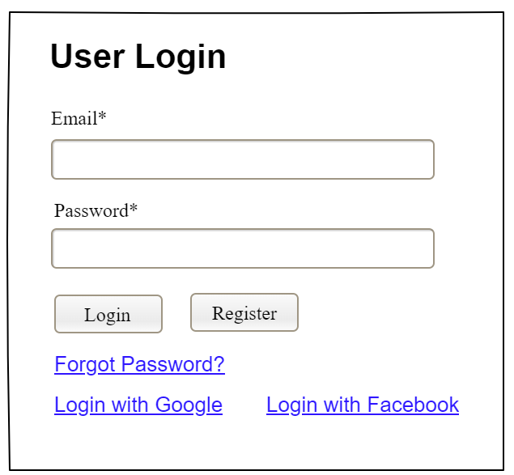

| **Field Name** | **Field Type** | **Description** |
| --- | --- | --- |
| Email* | Text Box | This is for user to input valid email address for logging in |
| Password* | Password Box | This is for user to input password for logging in |
| Login | Button | User clicks to authenticate him/herself into the system with provided email & password |
| Register | Button | User clicks to redirect to the User Register page for registering new user account to access the system |
| Forgot Password? | Hyperlink | User clicks to redirect to the Password Reset page for resetting his/her forgot password |
| Login with Google | Hyperlink | Allow user to login with his/her Google account |
| Login with Facebook | Hyperlink | Allow user to login with his/her Facebook account |

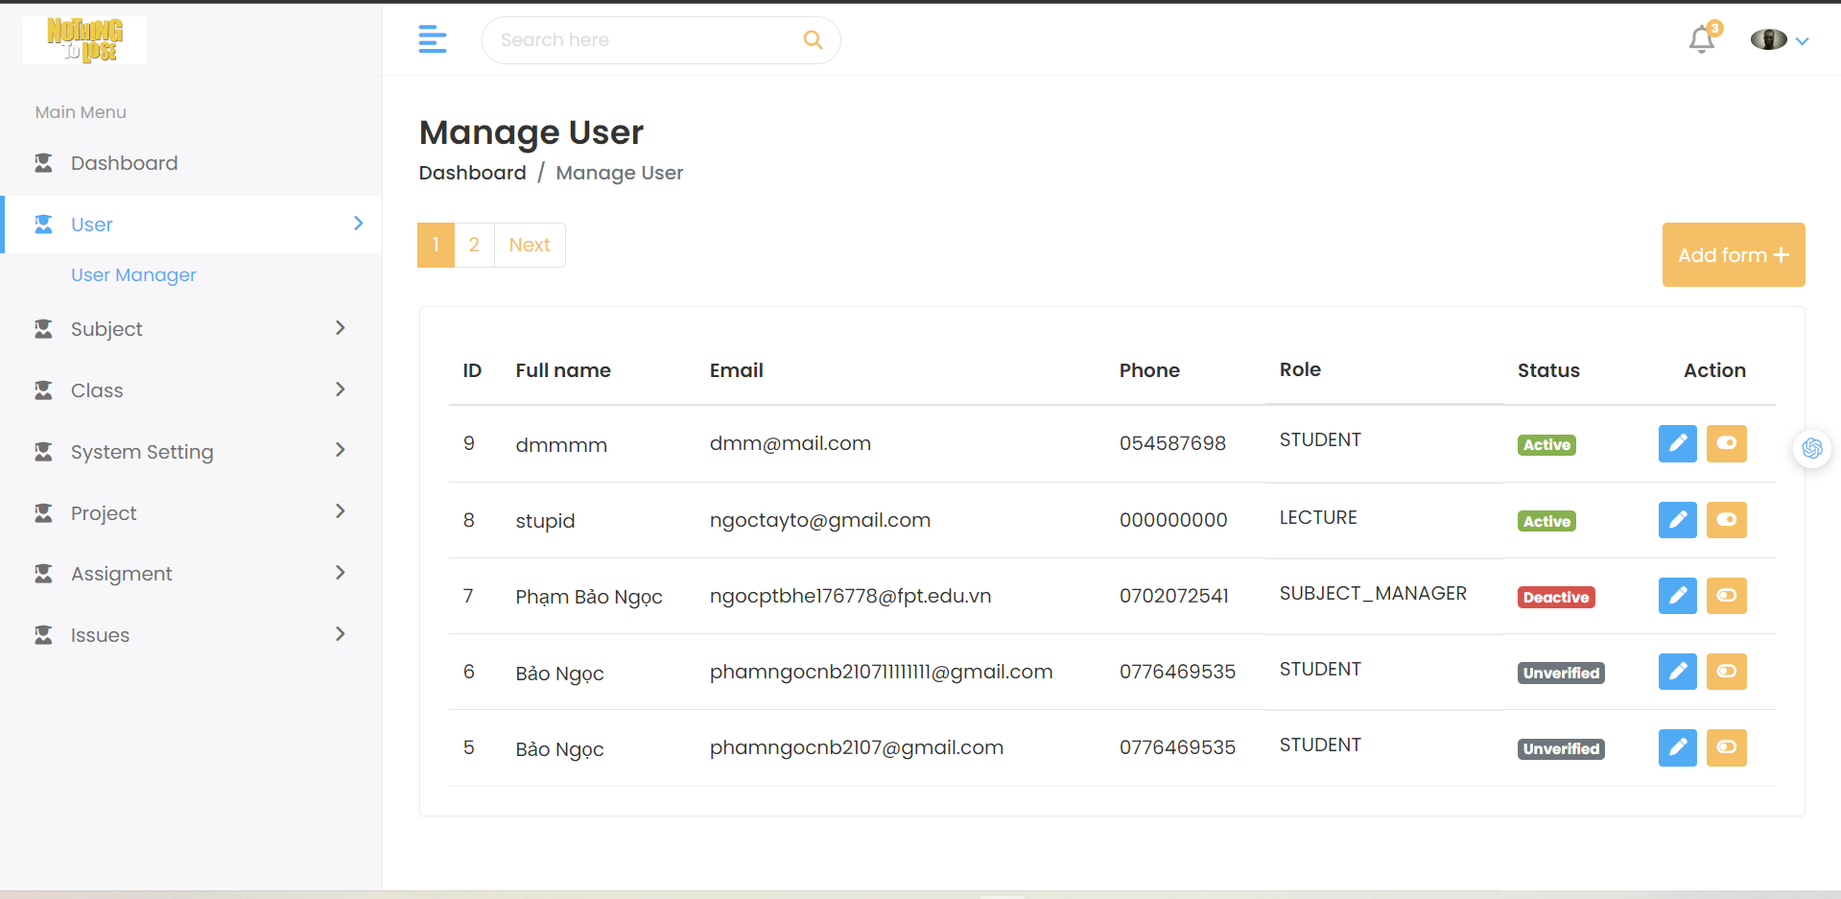

| **Field Name** | **Field Type** | **Description** |
| --- | --- | --- |
| **user** | **none** | show information about the user as full name , id , email , phone , role , status . |
| **Status** | **span** |  |
| **edit** | **button** | Often used to allow users to edit data or perform tasks related to modifying the content of the table. |
| **change status** | **button** | Related to changing user status in the table (Active, Deactivate or Unverified). |

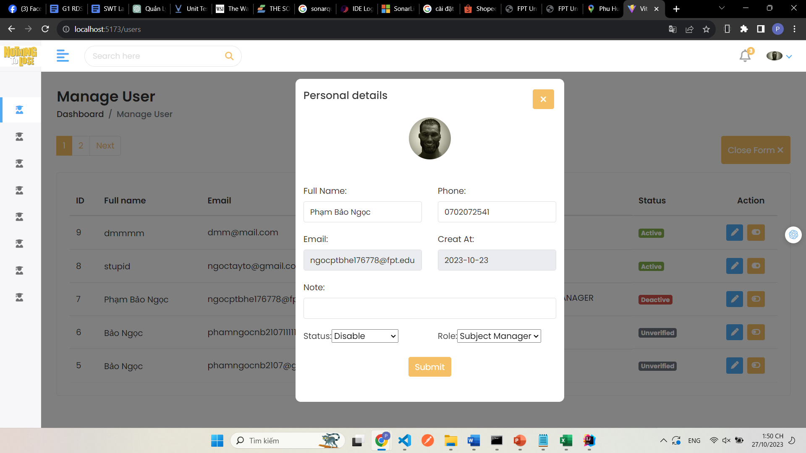

| **Field Name** | **Field Type** | **Description** |
| --- | --- | --- |
| **Full Name** | **Text Box** | This is for the user to input valid user name |
| **Phone Number** | **Text Box** | This is for the user to input valid user phone number |
| **Email** | **Text Box** | This is to show user verified email |
| **Create At** | **Text Box** | This is to show user account created date |
| **Note** | **Text Box** | This is for the user to input an admin note for this account |
| **Status** | **Combo Box** | User select option in combo box to assign user status |
| **Role** | **Combo Box** | User select option in combo box to assign role for this user |

## **System Setting Management**

**2.1 View system settings**

This screen allows users to see system setting list

**Screen Layout:** 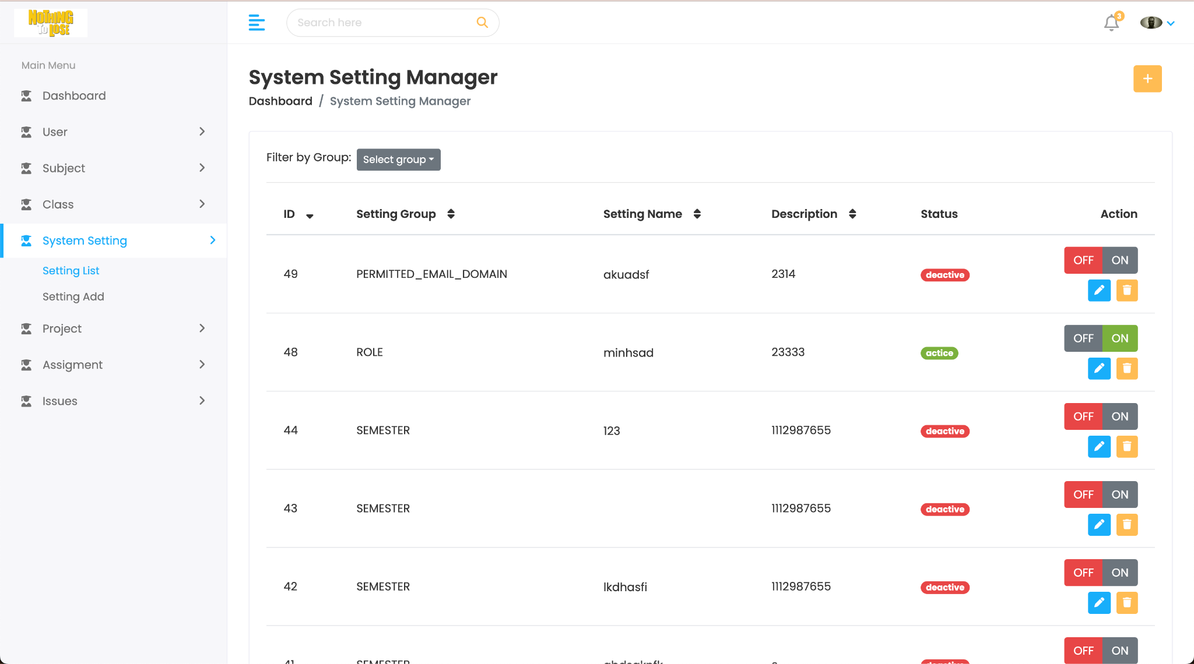

| **Field Name** | **Field Type** | **Description** |
| --- | --- | --- |
| **setting group** | **none** | show information about group of setting |
| **setting name** | **none** | show information about name of setting. |
| **Status** | **span** | show information about status of setting |
| **ON/OFF** | **button** | allow users actice/deactive setting |
| **edit** | **button** | Often used to allow users to edit data or perform tasks related to modifying the content of the table. |
| **delete** | **button** | Related to deleting data content in the table. |

**2.2 New system setting**

This screen allows users to create new system setting

**Screen Layout:**

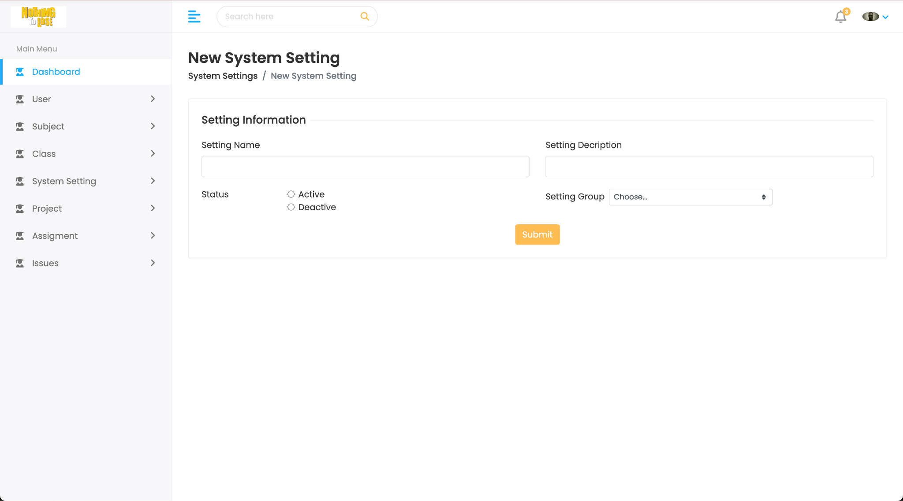

| **Field Name** | **Field Type** | **Description** |
| --- | --- | --- |
| **Setting Name** | **Text Box** | This is for user to input valid setting name |
| **Setting Description** | **Text Box** | This is for user to input valid setting description |
| **Setting Group** | **Combo Box** | User select option in combo box to choose group for setting |
| **Status** | **Radio** | User clicks one of two status of this setting |

### 

## **Subject Management**

### **3.1 New Subject**

This screen allows users to add new subjects to the system.

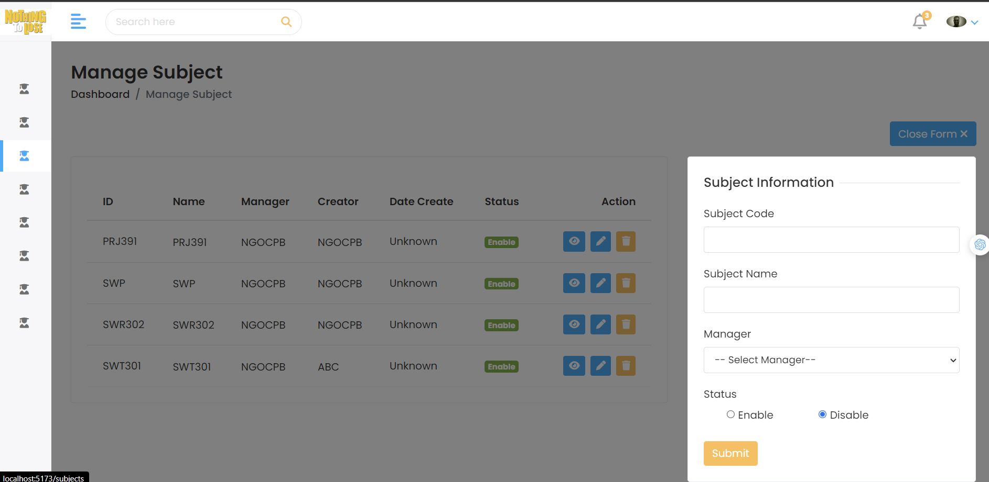

| **Field Name** | **Field Type** | **Description** |
| --- | --- | --- |
| Subject Code | Text Box | This is for user to input valid subject code |
| Subject Name | Text Box | This is for user to input valid subject name |
| Manager | Combo Box | User select option in combo box to assign manager for this subject |
| Status | Radio | User clicks one of two status of this subject |

### **3.2 Subject Detail**

This screen allows users to update the existing subject in the system.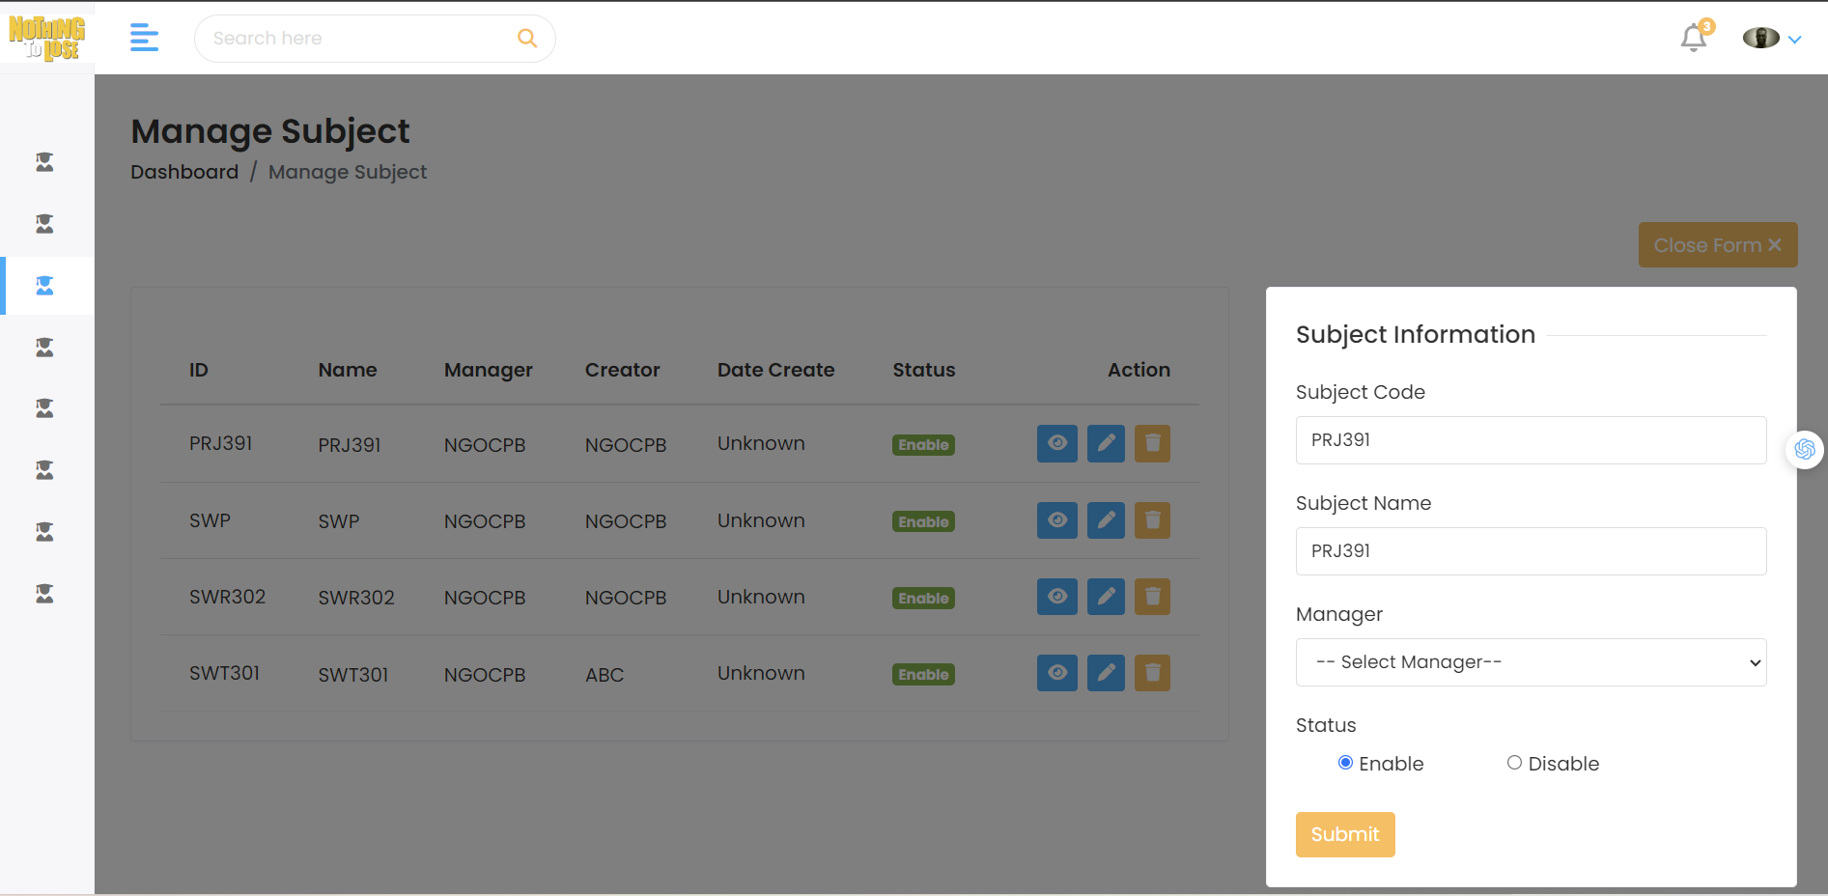

| **Field Name** | **Field Type** | **Description** |
| --- | --- | --- |
| Subject Code | Text Box | This is for user to update by valid subject code |
| Subject Name | Text Box | This is for user to update by valid subject name |
| Manager | Combo Box | User select option in combo box to change manager for this subject |
| Status | Radio | User clicks one of two status of this subject |

### **3.3 Subject Assignment List**

This screen allows users to see subject assignment list

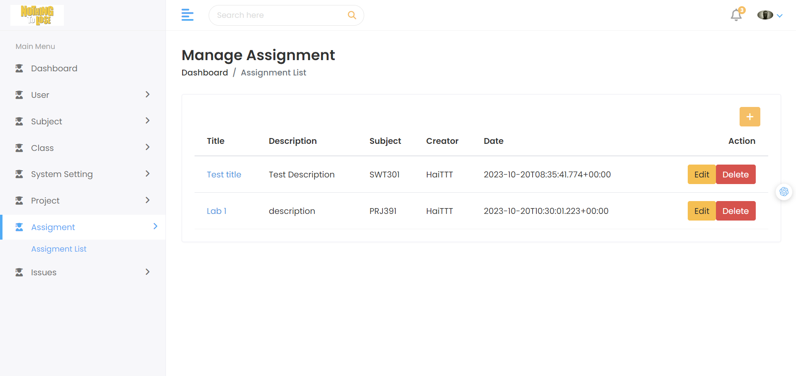

| **Field Name** | **Field Type** | **Description** |
| --- | --- | --- |
| **subject** | **none** | Represents the topic of the subject and displays the subjects that have assignments |
| **creator** | **none** | Display information about the assignment creator. |
| **edit** | **button** | Often used to allow users to edit data or perform tasks related to modifying the content of the table. |
| **delete** | **button** | Related to deleting data content in the table. |

### **3.4 Subject Assignment Add**

This screen allows users to add new subjects assignment to the system.

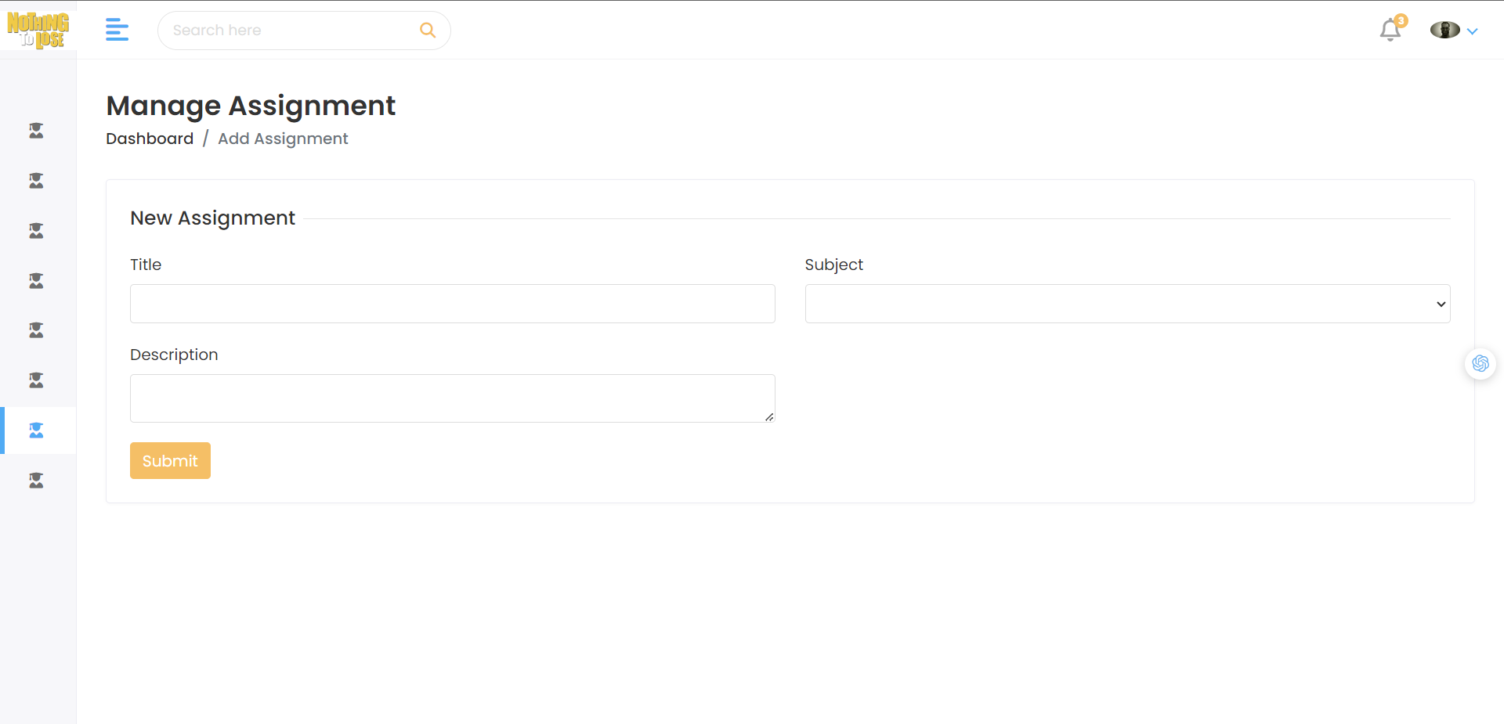

| **Field Name** | **Field Type** | **Description** |
| --- | --- | --- |
| **title** | **input** | The user input the title for the assignment |
| **description** | **input** | The user input the description or detailed information about the assignment. |
| **subject** | **Combo box** | The user selects the option in the combo box to change the subject for this topic |

## **Class Management**

## **Project Management**

## **Synchronization**

## 

# **IV. Appendix**

## **1. Assumptions & Dependencies**

AS-1: The project team will have the necessary skills and experience to complete the project successfully.

AS-2: The stakeholders will be available to provide timely feedback and approvals.

AS-3: The project will not be significantly impacted by external factors, such as changes in technology.

AS-4: faculty and administrative staff are adequately trained to use the new student management system effectively.

AS-5: This system will comply with all applicable information security laws and regulations.

AS-6:

DE-1: The project is dependent on the successful integration of student data from various sources, such as enrollment systems, course registration, and grading systems.

DE-2: Dependencies exist on upgrading hardware infrastructure to support the new software. This includes server capacity and network improvements.

DE-3: The training of faculty and staff depends on the completion of software development. Delays in development will affect the training schedule.

DE-4: Dependencies exist on timely security audits to ensure the protection of student data. Delays in security audits may impact project timelines.

## **2. Limitations & Exclusions**

LI-1: The project has a limited time of 3 months(one semester) to implement the project student management system. There will be no resources to extend this period.

LI-2: The project uses limited resources, includes 5 development members and costs no money.

EX-1: Online Payment Feature: The project does not include an online payment feature for tuition fees or project fees.

EX-2: Integration with University Fee System: The project does not deeply integrate with the university's tuition fee system. Tuition fees will be managed through a different system.

EX-3: Advanced System Features: The project does not encompass advanced features like study note management or student event management. These features may be considered for future projects.

## **3. Messages List**

| **#** | **Message code** | **Message Type** | **Context** | **Content** |
| --- | --- | --- | --- | --- |
| 1 | MSG01 | In line | There is not any search result | No search result. |
| 2 | MSG02 | Pop-up, with red text | Input-required fields are empty | The * field is required. |
| 3 | MSG03 | Toast message | Updating asset(s) information successfully | Update asset(s) successfully. |
| 4 | MSG04 | Toast message | Adding new asset successfully | Add assets successfully. |
| 5 | MSG05 | Toast message | Confirming email of asset hand-over is sent successfully | A confirmation email has been sent to {email_address}. |
| 6 | MSG06 | Toast message | Resetting asset information successfully | Return asset(s) successfully. |
| 7 | MSG07 | Toast message | Deleting asset information successfully | Delete asset(s) successfully. |
| 8 | MSG08 | Pop-up, with red text | Input value length > max length | Exceed max length of {max_length}. |
| 9 | MSG09 | In line | Username or password is not correct when clicking sign-in | Incorrect username or password. Please check again. |
| 10 | MSG10 |  |  |  |